**GSCA 2019 Film Expo & Filmmaker Symposium**

**March 11-13, 2019**

**Los Angeles, California**

**New Films, Films in Production, and Projects in Development Descriptions**

**New Films**

**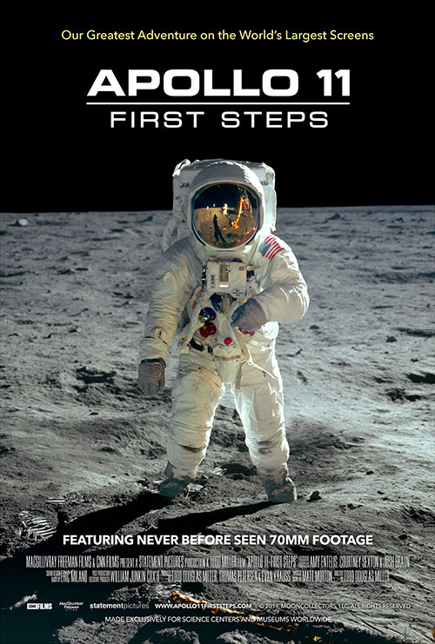Apollo 11: First Steps**

Rough cut  
Presented in 2D  
**Release:** May 17, 2019  
**Formats:** 2D and 3D, 15/70, IMAX Digital, IMAX Laser, DCI-compliant Digital, DCI-compliant Laser, Dome-customized 15/70, Fulldome Digital  
**Length:** 40:00; 20-minute version in all 2D digital formats and fulldome  
**Producer:** Statement Pictures and CNN Films  
**Distributor:** MacGillivray Freeman Films  
**Contact:** Patty Collins, [pcollins@macfreefilms.com](mailto:pcollins@macfreefilms.com)

Timed to coincide with the 50th anniversary of the first lunar landing, *Apollo 11: First Steps* gives a thrilling cinematic experience that showcases the real-life moments of the famed Apollo 11 mission. With never-before-seen 70mm footage and a newly discovered trove of audio recordings, the filmmakers reconstruct the Apollo 11 mission in astonishing detail. Audiences will experience the exhilarating final moments of preparation, the countdown, liftoff, landing, and return of this historic mission that united the world—one of mankind’s greatest achievements. An immersive giant screen experience that takes you straight to the heart of this intense scientific and human endeavor, *Apollo 11: First Steps* leaves us marveling at human ingenuity and the impulse that led humanity to space. Produced by Statement Pictures and CNN Films and distributed by MacGillivray Freeman Films.

**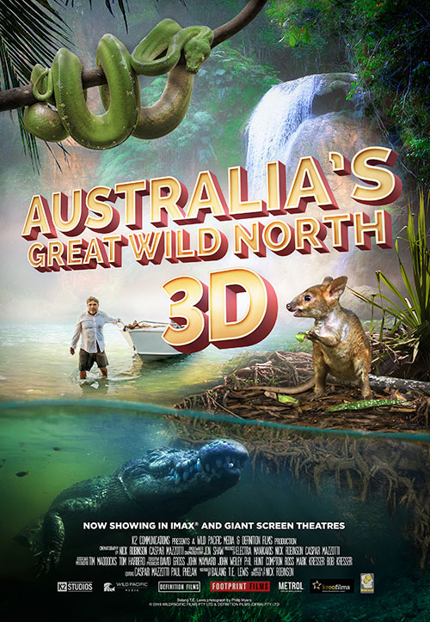Australia’s Great Wild North**

Presented in 3D  
**Release:** June 2018  
**Formats:** 2D and 3D, 15/70, IMAX Digital, IMAX Laser, DCI-compliant Digital, DCI-compliant Laser, Fulldome Digital  
**Length:** 36:30  
**Producer:** Wild Pacific Media and Definition Films  
**Distributor:** K2 Studios  
**Contact:** Mark Kresser, [mark\_kresser@k2communications.com](mailto:mark_kresser@k2communications.com)  
**Web:** [australiasgreatwildnorth.com](http://australiasgreatwildnorth.com)

Few places on earth remain as wild and pristine as the Top End of Australia. It is a land that time forgot. A place with some of the richest wetlands and oldest rainforests where ancient people lived in harmony with this wild land and her beasts. The largest dinosaurs called this land home and left their footprints in these ancient rocks, and one of their deadly relatives still lives there today. Come on this epic scientific adventure with Tommy, our native Aboriginal guide, as we venture through some of the world's most beautiful landscapes and travel deep into saltwater crocodile country.

**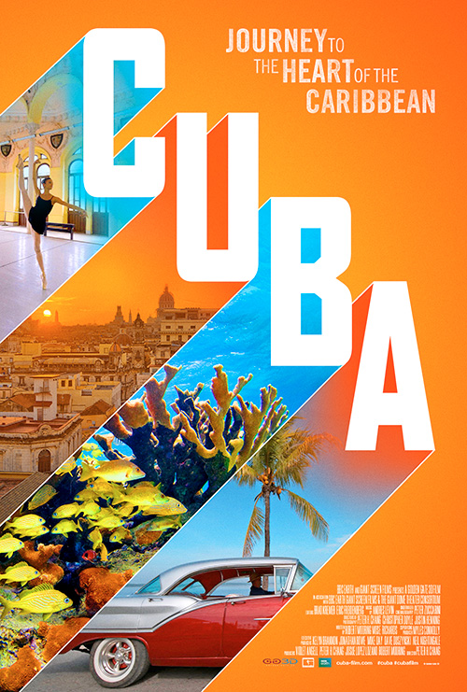Cuba**

Presented in 2D  
**Release:** Available now in 2D; 3D available May 2019 **Formats:** 2D and 3D, 15/70, IMAX Digital, IMAX Laser, DCI-compliant Digital, DCI-compliant Laser, Fulldome Digital  
**Length:** 43:50 and 20:00  
**Producer:** Golden Gate 3D  
**Distributor:** Giant Screen Films  
**Contact:** Mark Katz, [mkatz@gsfilms.com](mailto:mkatz@gsfilms.com)  
**Web:** [cuba-film.com](http://cuba-film.com)

*Cuba* tells the powerful story of a land preserved in time yet poised on the cusp of dramatic change. The nation’s vibrant culture, meticulously maintained colonial architecture, and pristine ecosystems provide a vivid window into the island's history and spirit. *Cuba* will transport audiences across breathtaking landscapes, under the ocean surface to iridescent reefs, and into streets throbbing with music and dance in the heart of Havana. Through the eyes of Cuban artists, historians, and scientists, the film provides an intimate look this vivacious island nation. Filmed exclusively for the giant screen format, *Cuba* reveals why Cuba continues to stir the imagination of the world. *Cuba* is produced by Golden Gate 3D, in association with BBC Earth, Giant Screen Films, and the Giant Dome Theater Consortium.

**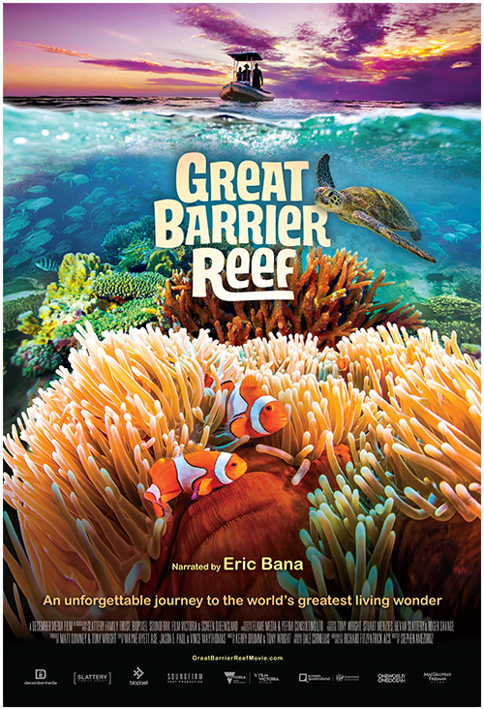Great Barrier Reef**

Presented in 3D  
**Release:** July 2018  
**Formats:** 2D and 3D, 15/70, IMAX Digital, IMAX Laser, DCI-compliant Digital, DCI-compliant Laser, Dome-customized 15/70, Fulldome Digital  
**Length:** 42:30  
**Producer:** December Media  
**Distributor:** MacGillivray Freeman Films  
**Contact:** Patty Collins, pcollins@macfreefilms.com  
**Web:** [greatbarrierreeffilm.com](http://greatbarrierreeffilm.com)

No structure built by living creatures compares to the size and majesty of the Great Barrier Reef—spanning more than 1,400 miles off the coast of Australia and home to countless unique species of aquatic life. Narrated by acclaimed Australian actor Eric Bana, *Great Barrier Reef* explores the awe of this natural environment and introduces the visionaries and “citizen scientists” who help us better understand and protect the reef. Grab your mask and snorkel and join an unforgettable adventure with majestic manta rays and sea turtles, witness the birth of baby seahorses, participate in a coral watch expedition, and discover the exotic splendor of fluorescent corals at night as *Great Barrier Reef* captures the natural beauty and exquisite strangeness of this awesome, and vibrant living world. A December Media film produced in association with Slattery Family Trust, Biopixel, Soundfirm, Film Victoria, and Screen Queensland and distributed by MacGillivray Freeman Films.

**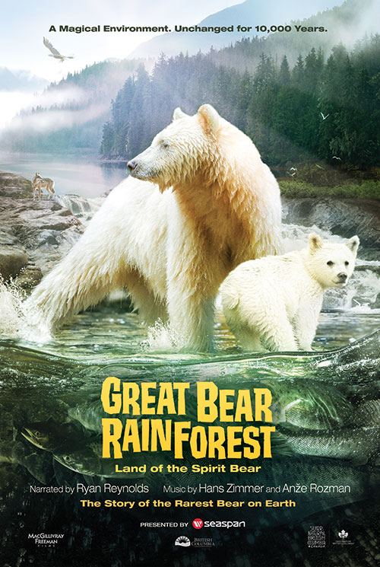Great Bear Rainforest**

Presented in 3D  
**Release:** February 15, 2019  
**Formats:** 2D and 3D, 15/70, IMAX Digital, IMAX Laser, DCI-compliant Digital, DCI-compliant Laser, Dome-customized 15/70, Fulldome Digital, Fulldome  
**Length:** 40:00  
**Producer:** Spirit Bear Entertainment  
**Distributor:** MacGillivray Freeman Films  
**Contact:** Patty Collins, [pcollins@macfreefilms.com](mailto:pcollins@macfreefilms.com)  
**Web:** [greatbearrainforestfilm.com](http://greatbearrainforestfilm.com)

*Great Bear Rainforest* is the story of one of the rarest animals on Earth—the fabled all-white Spirit Bear—and its ancient forest home. Hidden from the outside world, the Great Bear Rainforest is one of the planet’s most exquisite and secluded wildernesses. Found on Canada’s rugged Pacific coast, it is the largest temperate coastal rainforest in the world and is home to indigenous First Nations peoples, who have provided stewardship of the forest for millennia. Embark on a remarkable journey into a land of grizzlies, coastal wolves, sea otters, and humpback whales—and discover the secret world of the Spirit Bear. Narrated by Ryan Reynolds. *Great Bear Rainforest* is a Spirit Bear Entertainment film presented by Seaspan in association with Destination British Columbia and distributed by MacGillivray Freeman Films.

**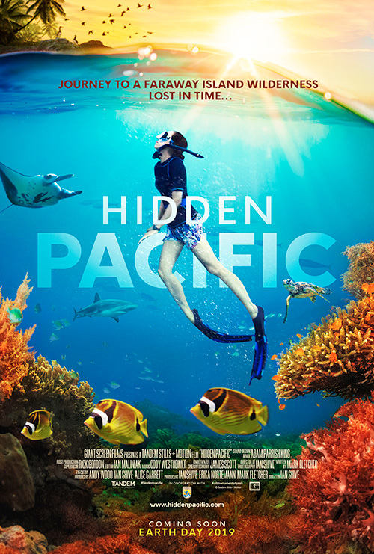Hidden Pacific**

Presented in 2D  
**Release:** May 2019  
**Formats:** 2D and 3D, IMAX Digital, IMAX Laser, DCI-compliant Digital, DCI-compliant Laser  
**Length:** 42:21 and 20:00  
**Producer:** Tandem Stills + Motion  
**Distributor:** Giant Screen Films  
**Contact:** Mark Katz, [mkatz@gsfilms.com](mailto:mkatz@gsfilms.com)  
**Web:** [hiddenpacific.com](http://hiddenpacific.com)

*Hidden Pacific* is a pioneering film that profiles some of the Pacific Ocean's most beautiful islands and marine national monuments—breathtaking places that will leave audiences with a deep-felt appreciation for the beauty of nature untouched by civilization. The storied histories of Palmyra, Midway and other atolls—from the WWII Pacific Theater to their present environmental recovery and ecological research initiatives—provide the platform from which the film explores a diversity of science and human stories. *Hidden Pacific* is produced by Tandem Stills + Motion, in cooperation with the U.S. Fish & Wildlife Service and affiliated organizations, which provided the filmmakers with unprecedented access to the bio-secure zones of the marine monuments. Launching globally in museum, zoo, aquarium, giant screen, and IMAX® cinemas on Earth Day weekend 2019.

**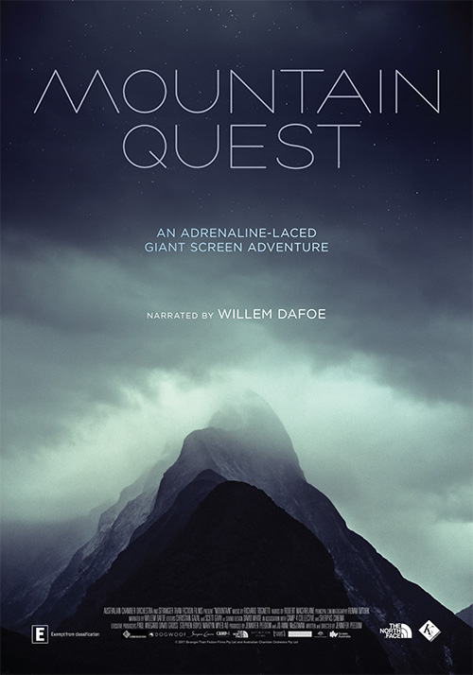Mountain Quest**

Presented in 3D  
**Release:** 2018  
**Formats:** 2D and 3D, IMAX Digital, IMAX Laser, DCI-compliant Digital, DCI-compliant Laser, Fulldome Digital  
**Length:** 38:21   
**Producer:** Stranger Than Fiction Films  
**Distributor:** K2 Studios  
**Contact:** Mark Kresser, [mark\_kresser@k2communications.com](mailto:mark_kresser@k2communications.com)

A lone climber, suspended hundreds of feet in the air, struggles to find the next finger hold, defining progress in inches. The dramatic visuals immerse us in a gripping contest of human determination versus the reality of gravity’s potent grip. *Mountain Quest* explores the precarious relationship of humanity’s quest to scale some of the world’s highest places, while also revealing the scientific and technological advances that have enabled us to conquer these peaks, exposing the heartbeat of the human soul.

**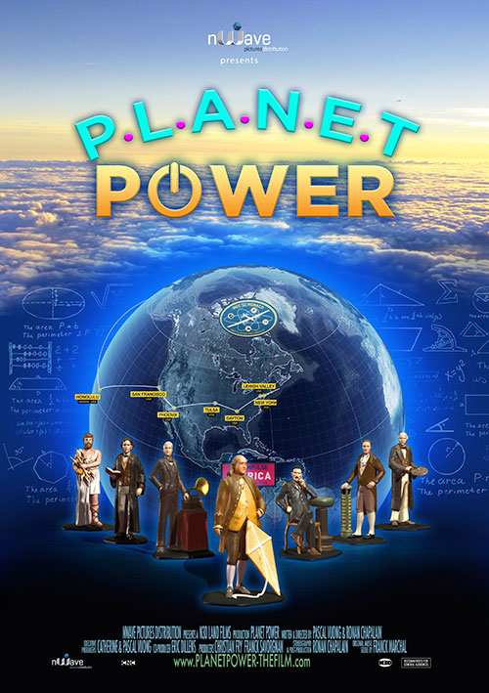Planet Power**

(20-minute version)  
Presented in 3D  
**Release:** March 2018  
**Formats:** 2D and 3D, IMAX Digital, IMAX Laser, DCI-compliant Digital, DCI-compliant Laser, Fulldome Digital  
**Length:** 20:31  
**Producer:** N3D Land Films  
**Distributor:** nWave Pictures Distribution  
**Contact:** Janine S. Baker, Goedele Gillis, [info@nwave.com](mailto:info@nwave.com)  
**Web:** [planetpower-thefilm.com](http://planetpower-thefilm.com)

*Planet Power* explores the history of electricity—from the first spark created by man’s hand to today’s industrial power plants. We meet scientists who changed the world, like Faraday, Franklin, and Tesla, and we glimpse the future, as Solar Impulse becomes the first plane to complete a round-the-world flight powered only by the sun. With a mix of chalk animation, CGI, archival footage, and spectacular aerials, the film also explores the challenges ahead: how to meet the growing energy needs of our industrialized world, while also protecting the health of our planet.

**Superpower Dogs**

Presented in 3D  
**Release:** March 15, 2019  
**Formats:** 2D and 3D, 15/70, IMAX Digital, IMAX Laser, DCI-compliant Digital, DCI-compliant Laser, Dome-customized 15/70, Fulldome Digital  
**Length:** 44:00  
**Producer/Distributor:** Cosmic Picture and IMAX  
**Contact:** Gina Glen, [gglen@imax.com](mailto:gglen@imax.com); Doris Babiera, [dbabiera@imax.com](mailto:dbabiera@imax.com); Antonietta Monteleone, [antonietta@cosmicpicture.com](mailto:antonietta@cosmicpicture.com); John Wickstrom, [john@cosmicpicture.com](mailto:john@cosmicpicture.com)  
**Web:** [superpowerdogs.com](https://superpowerdogs.com)

Join an immersive IMAX adventure to experience the life-saving superpowers and extraordinary bravery of some of the world’s most amazing dogs. In this inspiring true story narrated by Chris Evans, our best friends are also real-life superheroes. Journey around the globe to meet remarkable dogs who save lives and discover the powerful bond they share with their human partners. Follow ‘Halo,’ a rookie puppy training to join one of the most elite disaster response teams in America. Meet ‘Henry,’ an avalanche rescue expert in the Canadian Rockies, ‘Reef,’ a Newfoundland lifeguard with the Italian coastguard, ‘Ricochet,’ a Californian surf legend helping people with special needs, and the Bloodhound brothers, ‘Tipper and Tony,’ who are leading the fight to save endangered species in Africa. As we discover the incredible abilities of dogs and the astonishing science behind their superpowers, we’ll never look at our best friends the same way again!

**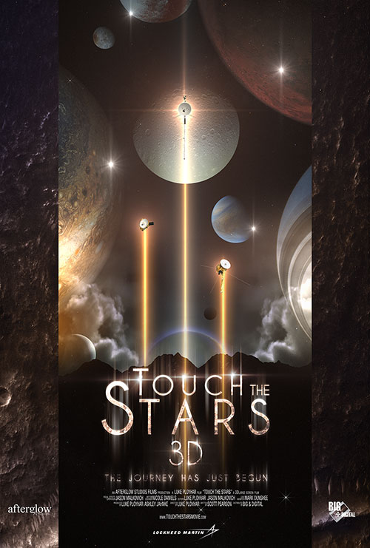Touch the Stars 3D**

Presented in 3D  
**Release:** February 2, 2019  
**Formats:** 2D and 3D, IMAX Digital, IMAX Laser, DCI-compliant Digital, DCI-compliant Laser, Fulldome Digital  
**Length:** 38:00 (26:00 DCI-compatible version also)  
**Producer:** Afterglow Studios  
**Distributor:** BIG & Digital, LLC  
**Contact:** Tina Ratterman, [tratterman@biganddigital.com](mailto:tratterman@biganddigital.com)  
**Web:** [touchthestarsmovie.com](http://touchthestarsmovie.com)

*Touch the Stars* dramatically showcases the robotic spacecraft used in exploration of our solar system and the galaxy beyond. The film traces the path to space through the history of NASA’s probes, orbiters, and landers—from the heart of our solar system and the surface of its planets and moons to the grand tour of the Voyager spacecraft through the outer planets and beyond. Created with the cooperation of NASA and Lockheed Martin, and using the latest high definition imagery and scientific data, *Touch the Stars* engages audiences through the use of real footage and 3-dimensional vistas, transporting us to planets and distant stars alongside these heroic robot explorers for an unforgettable voyage. *Touch the Stars* is the second of a trilogy of films from Afterglow Studios. *Space Next 3D* released in December 2015 and was the GSCA Best Visual Effects Winner in 2016. Lockheed Martin is a partner of *Touch the Stars* and the third film. Fulldome will release in March and 180-Fulldome will release summer 2019 in both run times.

**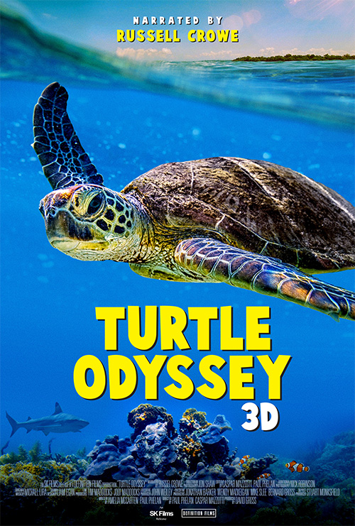Turtle Odyssey**

Presented in 3D  
**Release:** July 2018  
**Formats:** 2D and 3D, 15/70, IMAX Digital, IMAX Laser, DCI-compliant Digital, DCI-compliant Laser, Dome-customized 15/70, Fulldome Digital  
**Length:** 41:00  
**Producer:** Definition Films  
**Distributor:** SK Films  
**Contact:** Amber Hawtin, [ahawtin@skfilms.ca](mailto:ahawtin@skfilms.ca)  
**Web:** [turtleodysseyfilm.com](http://www.turtleodysseyfilm.com/)

Sea turtles are some of Earth’s most ancient and majestic creatures. For over 100 million years, they have traversed the seas, surviving multiple mass extinctions and playing critical roles in maintaining healthy marine food webs. Not only do these friendly animals captivate us as they peacefully glide through the ocean, but their personal journeys of survival are equally fascinating. These remarkable reptiles will traverse thousands of kilometres of open ocean for as long as 50 years and then, from half a world away, migrate with mysterious precision back to the very beach where they were born—to lay eggs that will become the foundation of the next generation. With the turtles guiding them, Turtle Odyssey’s crew voyaged the same thousands of kilometres to capture the wonders of their habitats. Come on an adventure, encountering many strange and compelling creatures, from enormous breaching whales to the coral wonderland of the Great Barrier Reef—all filmed in stunning 3D. Playful sea lions, tiny sea horses, and vibrant clown fish will float right out into the theatre! Sea turtles remind us just how interconnected we all are in this amazing world and audiences will be moved to cherish them even more.

**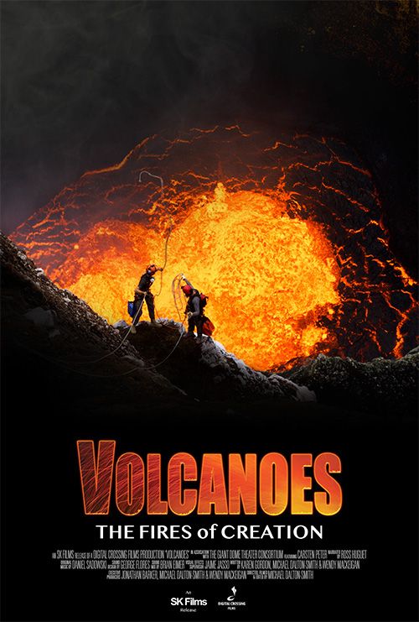Volcanoes—The Fires of Creation**

Presented in 3D  
**Release:** Fall 2018  
**Formats:** 2D and 3D, 15/70, IMAX Digital, IMAX Laser, DCI-compliant Digital, DCI-compliant Laser, Dome-customized 15/70, Fulldome Digital  
**Length:** 42:01, shorter version also available  
**Producer:** Digital Crossing Films  
**Distributor:** SK Films  
**Contact:** Amber Hawtin, ahawtin@skfilms.ca  
**Web:** [volcanoesfilm.com](http://volcanoesfilm.com" \t "_blank)

*Volcanoes—The Fires of Creation* is a tale of science, culture, and thrilling adventure. For billions of years, from the continents to the air we breathe and even life itself, volcanoes have helped forge the world we know creating extraordinary ecosystems and wildlife habitats. With over 500 active volcanoes, the Earth is bursting at the seams with these forces of mass construction. The story of volcanoes is the story of the planet’s creation and the story of us. With intrepid explorer Carsten Peter, descend to a lava lake in Vanuatu and visit incredible acid ponds, geysers and mineral deposit fields in Ethiopia. Visit the archaeological ghost town of Pompeii, hydrothermal vents at the bottom of the ocean and witness the devastating effects of the 2018 Kilauea eruption in Hawaii. Audiences will be on the edge of their seats as they discover molten worlds in this adrenaline-filled, immersive experience.

**Films in Production**

### Ancient Caves

* Presented in 2D
* **Release:** 2020
* **Formats:** 2D, 15/70, IMAX Digital, IMAX Laser, DCI-compliant Digital, DCI-compliant Laser, Dome-customized 15/70, Fulldome Digital
* **Length:** 45:00
* **Producer:** Oceanic Research Group
* **Distributor:** MacGillivray Freeman Films
* **Contact:** Patty Collins, [pcollins@macfreefilms.com](mailto:pcollins@macfreefilms.com)

Dr. Gina Moseley is a scientist on a mission as she travels the world in her quest to unlock the secrets of the Earth’s ancient climate in the most unlikely of places—ancient caves. Her need for underwater samples leads her to world-renowned cave diver Brian Kakuk. Brian can go where Gina can’t, and together they can reach places very few humans will ever go. Ancient Caves brings science and adventure together as the team embarks on an expedition to some of the world’s most extreme caves, both above and below the water, to learn about rapid climate change and how it has, and might, impact human civilization. Ancient Caves is being shot in dome-native format in conjunction with the Giant Dome Theater Consortium.

### Antarctica 3D: Into the Unknown

* Presented in 2D
* **Release:** 2020
* **Formats:** 2D and 3D, 15/70, IMAX Digital, IMAX Laser, DCI-compliant Digital, DCI-compliant Laser, Dome-customized 15/70, Fulldome Digital
* **Length:** 42:00
* **Producer:** BBC Studios
* **Distributor:** BBC Earth
* **Contact:** Jonathan Williams, [jonathan.williams@bbc.com](mailto:jonathan.williams@bbc.com)

Antarctica is the most extreme continent on our planet—higher, colder, and even drier than any other on Earth, and although it is thousands of miles away, what happens here affects every single one of us. Temperatures can plummet to -70C, freezing its ocean waters, yet even in this remote, hostile habitat there is an abundance of life and beauty. To discover exactly how life can thrive in such a desolate place, this giant screen adventure will tell the story of a year in the Antarctic and reveal what courageous scientists are learning about the wildlife of Earth’s last great wilderness.

### Asteroid Impact

* Presented in 3D
* **Release:** October 4, 2019
* **Formats:** 2D and 3D, 15/70, IMAX Digital, IMAX Laser, DCI-compliant Digital, DCI-compliant Laser, Dome-customized 15/70, Fulldome Digital
* **Length:** 40:00
* **Producer:** IMAX Corporation, Apophis Pictures LLC, Huahuang Pictures
* **Distributor:** IMAX
* **Contact:** Gina Glen, [gglen@imax.com](mailto:gglen@imax.com)

Asteroid Impact will reveal the origins of asteroids and the effects of previous Earth impacts. Delve into how these celestial bodies have shaped life on primitive Earth and the threat they pose to our planet today. Learn how we monitor them in order to stay out of their deadly path. Through the eyes of scientists tasked with keeping watch over our planet, see the devastating effects of a hypothetical asteroid impact, portrayed on a grand scale as never seen before. The ways we might prevent a cosmic collision are also explored. This new IMAX documentary will make clear it’s not a question of if an asteroid will strike our planet again, but when.

### Back From the Brink: Saved From Extinction

* Presented in 2D
* **Release:** Fall 2019
* **Formats:** 2D and 3D, 15/70, IMAX Digital, IMAX Laser, DCI-compliant Digital, DCI-compliant Laser, Dome-customized 15/70, Fulldome Digital  
  **Length:** 40:00
* **Producer:** Roam and Sean Casey (director)
* **Distributor:** Cosmic Picture
* **Contact:** Antonietta Monteleone, [antonietta@cosmicpicture.com](mailto:%20antonietta@cosmicpicture.com)
* **Web:** [cosmicpicture.com/films/back-from-the-brink/](http://cosmicpicture.com/films/back-from-the-brink/)

Back from the Brink, from award-winning giant screen director Sean Casey, is an immersive film that will explore extraordinary true stories of animals rescued from the brink of extinction. Audiences will meet California’s endearing Channel Island Fox, the smallest canid in the world, imperiled by the introduction of Golden Eagles to their only habitat. We will witness the stunning migration of the Christmas Island Red Crabs, thinned dangerously by the Crazy Ant invasion. And, finally, we journey to Yunnan, China, to find the enigmatic Golden Monkey, high on the most-endangered primates list, living in one of the most biodiverse and remote regions of the world. Back from the Brink, with real and inspiring conservation stories, will renew your hope that our threatened planet and all its inhabitants can be saved.

### Blue Whales

* Presented in 2D
* **Release:** March 2021
* **Formats:** 2D and 3D, 15/70, IMAX Digital, IMAX Laser, DCI-compliant Digital, DCI-compliant Laser, Dome-customized 15/70, Fulldome Digital
* **Length:** 42:00
* **Producer:** Oceanic Films
* **Distributor:** to be determined
* **Contact:** Hugh Pearson, [hugh@oceanicfilms.tv](mailto:hugh@oceanicfilms.tv)
* **Web:** [oceanicfilms.tv](http://oceanicfilms.tv)

Blue whales grow to 100 feet long and have a heart the size of a car, yet despite their great size, we know surprisingly little about them. With new scientific discoveries and the latest filming techniques we can now reveal the secret lives of blue whales, in a story made for the giant screen. We will follow a team of passionate scientists using the latest tech and “old fashion” science to reveal the blue whales’ epic migrations and intimate birthing grounds. In Mexico’s stunning Gulf of California and off the coast of Southern California we will film blue whales as never before. Come with us as we discover the mysteries of the largest animal that has ever lived, shown in life size on the giant screen—a truly awe-inspiring experience. Blue whales—the intimate story of an iconic character in an epic location. Oceanic Films are pleased to team up with Myles Connolly as supervising producer on this film. Myles is a 25-year giant screen veteran and has collaborated on more than 40 award-winning and Oscar-nominated films.

### Colours of China

* Presented in 2D
* **Release:** December 2019
* **Formats:** 2D, 15/70, IMAX Digital, IMAX Laser, DCI-compliant Digital, DCI-compliant Laser
* **Length:** 40:00
* **Producer:** Making Movies
* **Contact:** James Heyward, [info@makingmovies.co.nz](mailto:info@makingmovies.co.nz)
* **Web:** [makingmovies.co.nz/portfolio/colours-of-china/](http://makingmovies.co.nz/portfolio/colours-of-china/)

Five colours resonate through every layer of traditional and modern Chinese life. In the centre, is yellow, surrounded by blue for east, red for south, white for west, and black for the north. Guided by these profoundly influential colours, the audience embarks on a visual journey to discover the relationship between Colour and Chinese culture

### Cool Cities

* (formerly Cool Planet)
* Presented in 2D
* **Release:** March 2020
* **Formats:** 2D and 3D, 15/70, IMAX Digital, IMAX Laser, DCI-compliant Digital, DCI-compliant Laser, Fulldome Digital
* **Length:** 40:00
* **Producer:** Wild Pacific Media
* **Distributor:** K2 Studios
* **Contact:** Mark Kresser, [mark\_kresser@k2communications.com](mailto:mark_kresser@k2communications.com)

Cool Cities is an immersive global journey that explores how science and technology together with a cultural renaissance are opening the door to a sustainable future in many of the world’s most iconic mega-cities. The film will offer a practical vision for more livable cities that all people of all continents can connect with and be part of. We will showcase the human stories and real solutions that provide hope for a planet that cannot only survive but thrive for countless generations to come.

### Disneynature Penguins

* Presented in 2D
* **Release:** April 17, 2019
* **Formats:** 2D, IMAX Digital, IMAX Laser, DCI-compliant Digital, DCI-compliant Laser, Fulldome Digital
* **Length:** 90:00
* **Producer:** Disneynature
* **Distributor:** Walt Disney Studios
* **Contact:** Gina Glen, [gglen@imax.com](mailto:gglen@imax.com)
* **Web:** [nature.disney.com/penguins](http://nature.disney.com/penguins)

Disneynature’s all-new feature film Penguins is a coming-of-age story about an Adélie penguin named Steve who joins millions of fellow males in the icy Antarctic spring on a quest to build a suitable nest, find a life partner, and start a family. None of it comes easily for him, especially considering he’s targeted by everything from killer whales to leopard seals, who unapologetically threaten his happily ever after. From the filmmaking team behind Bears and Chimpanzee, Disneynature’s Penguins opens in theaters nationwide in time for Earth Day 2019.

### Into America's Wild

* Formerly MFF’s New Adventure Film
* Presented in 2D
* **Release:** February 2020
* **Formats:** 2D and 3D, 15/70, IMAX Digital, IMAX Laser, DCI-compliant Digital, DCI-compliant Laser, Dome-customized 15/70, Fulldome Digital
* **Length:** 40:00
* **Producer/ Distributor:** MacGillivray Freeman Films
* **Contact:** Patty Collins, [pcollins@macfreefilms.com](mailto:pcollins@macfreefilms.com)

A journey through time and place, this giant screen film will follow the trails made on land and sea that showcase our quest to explore our world. The film follows an adventurous Alaskan pilot and a Space Station astronaut, both Native Americans, who share a passion to inspire the next generation to seek new experiences in nature, discover math and science, and learn from history and other cultures. They’ll take audiences to spectacular locations, ancient homelands, hidden treasures and scenic byways, even into space. As they honor the past and reach toward the future, the film connects audiences to the trailblazer in us all.

### Ireland

* Presented in 2D
* **Release:** 2021
* **Formats:** 2D and 3D, 15/70, IMAX Digital, IMAX Laser, DCI-compliant Digital, DCI-compliant Laser, Dome-customized 15/70, Fulldome Digital
* **Length:** 40:00
* **Producer/ Distributor:** MacGillivray Freeman Films
* **Contact:** Patty Collins, [pcollins@macfreefilms.com](mailto:pcollins@macfreefilms.com)

Ireland invites worldwide giant screen audiences on an extraordinary and joyful film adventure. Premiering in 2020, this Emerald Isle film celebrates Ireland’s rich history, land and seascapes, language, arts, and music. A 40-minute showcase of the island nation’s natural beauty, Ireland also reaches for the soul of a country. Amid awe-inspiring locations such as Giant’s Causeway, Skellig Michael, and the Cliffs of Moher, the film follows Irish writer Manchán Magan on his quest to reconnect Irish people from around the world with their land, language, and stories. Premier violinist Patricia Treacey and four of her teen orchestra students join Manchán to lend an even greater insight into Irish traditions and culture through the lens of music. Along the way they’ll also meet scientists studying basking sharks and the adorable puffins of Skellig. From Dublin to Belfast, Kilkenny, Blarney Castle, and beyond, audiences will discover why they love Ireland.

### The Lion King

* Presented in 2D
* **Release:** July 19, 2019
* **Formats:** 2D, IMAX Digital, IMAX Laser, DCI-compliant Digital, DCI-compliant Laser, Fulldome Digital
* **Length:** TBD
* **Producer:** Fairview Entertainment & Walt Disney Pictures
* **Distributor:** Walt Disney Studios
* **Contact:** Gina Glen, [gglen@imax.com](mailto:%20gglen@imax.com)

From Disney Live Action, director Jon Favreau's all-new The Lion King journeys to the African savanna where a future king is born. Simba idolizes his father, King Mufasa, and takes to heart his own royal destiny. But not everyone in the kingdom celebrates the new cub's arrival. Scar, Mufasa's brother—and former heir to the throne—has plans of his own. The battle for Pride Rock is ravaged with betrayal, tragedy, and drama, ultimately resulting in Simba's exile. With help from a curious pair of newfound friends, Simba will have to figure out how to grow up and take back what is rightfully his.

### Lost Empire of Angkor

* Presented in 2D
* **Release:** April 2019
* **Formats:** 2D and 3D, 15/70, IMAX Digital, IMAX Laser, DCI-compliant Digital, DCI-compliant Laser, Fulldome Digital
* **Length:** 40:00
* **Producer:** Helio Projects Asia
* **Distributor:** K2 Studios
* **Contact:** Mark Kresser, [mark\_kresser@k2communications.com](mailto:mark_kresser@k2communications.com)

A civilization that rose to become the envy of the world, only to disappear...a mystery waiting to be unlocked by modern archaeologists, scientists and explorers.

### Out of Bounds

* Presented in 2D
* **Release:** October 2019  
  Formats: 2D and 3D, 15/70, IMAX Digital, IMAX Laser, DCI-compliant Digital, DCI-compliant Laser, Fulldome Digital
* **Length:** 40:00
* **Producer:** K2 Studios Wild Pacific Media
* **Distributor:** K2 Studios
* **Contact:** Mark Kresser, [mark\_kresser@k2communications.com](mailto:mark_kresser@k2communications.com)
* **Web:** [outofbounds-film.com/](http://outofbounds-film.com/)

Follow Australian Olympic gold medalist Torah Bright as she journeys along the great American Cordillera, the world’s longest chain of mountain ranges extending from Antarctica all the way to Alaska. On the journey, Torah will encounter world-class snow athletes, scientists and environmentalists. Discover the crucial role mountains play in our ecosystem and everyday life, while witnessing the most spectacular snowboard and ski action ever brought to the giant screen!

### Sea Lions: Life by a Whisker

* Presented in 2D
* **Release:** December 1, 2019
* **Formats:** 2D and 3D, 15/70, IMAX Digital, IMAX Laser, DCI-compliant Digital, DCI-compliant Laser, Dome-customized 15/70, Fulldome Digital
* **Length:** 45:00
* **Producer:** Definition Films
* **Distributor:** K2 Studios and K2 Films Australia
* **Contact:** David Gross, [David@definitionfilms.com](mailto:David@definitionfilms.com)

Between a jagged cliff face and a roaring ocean lives a colony of Australian Sea Lions. In an environment equally as harsh as it is beautiful, be immersed in a classic coming-of-age tale guided by one of Australia’s most unique, intelligent, and playful animals. Take an intimate journey inside the colony where a life of great intimacy, tenderness, and clumsiness must often give way to a life of great sacrifice and bravery. Exposed to the elements, life here can be brutal and more dramatic than any scripted drama. Dive into the world of a rare Australian Sea Lion pup—and meet the people who are trying to save her species.

### Secrets of the Universe

* Presented in 3D
* **Release:** May 24, 2019
* **Formats:** 2D and 3D, 15/70, IMAX Digital, IMAX Laser, DCI-compliant Digital, DCI-compliant Laser, Fulldome Digital
* **Length:** 40:00
* **Producer:** The Stephen Low Company
* **Distributor:** K2 Studios
* **Contact:** Mark Kresser, [mark\_kresser@k2communications.com](mailto:mark_kresser@k2communications.com)
* **Web:** [secretsoftheuniversefilm.com/](http://secretsoftheuniversefilm.com/)

We are at the beginning of a period of unprecedented technological advancement, catalyzing a new age of scientific discovery. Travel with us on this immersive giant screen film, as we explore the most exciting machines ever conceived by man, including the Large Hadron Collider and James Webb Space Telescope. See how these new experiments allow us to look deeper into our origins, and unveil the mysteries of dark energy, dark matter and extra dimensions.

### Snow

* Presented in 2D
* **Release:** Spring 2020
* **Formats:** 2D and 3D, IMAX Digital, IMAX Laser, DCI-compliant Digital, DCI-compliant Laser, Fulldome Digital
* **Length:** 40:00
* **Producer:** Ouragan Films
* **Distributor:** nWave Pictures Distribution
* **Contact:** Janine S. Baker, Goedele Gillis, [info@nwave.com](mailto:info@nwave.com)
* **Web:** [thefutureofsnow.com/](http://thefutureofsnow.com/)

A meteorologist follows the movement of a winter storm that will bring snow to several countries. As landscapes are transformed, he wonders how long this magical snow scene will last.

### Toy Story 4

* Presented in 2D
* **Release:** June 21, 2019
* **Formats:** 2D, IMAX Digital, IMAX Laser, DCI-compliant Digital, DCI-compliant Laser, Fulldome Digital
* **Length:** TBD
* **Producer:** Pixar Animation Studios
* **Distributor:** Walt Disney Studios
* **Contact:** Gina Glen, [gglen@imax.com](mailto:gglen@imax.com)

Woody has always been confident about his place in the world and that his priority is taking care of his kid, whether that’s Andy or Bonnie. But when Bonnie adds a reluctant new toy called “Forky” to her room, a road trip adventure alongside old and new friends will show Woody how big the world can be for a toy.

**Projects in Development**

**Dinosaurs of Antarctica**

* **Release:** 2020
* **Formats:** 2D and 3D, 15/70, IMAX Digital, IMAX Laser, DCI-compliant Digital, DCI-compliant Laser, Dome-customized 15/70
* **Length:** 40:00 and 20:00
* **Producer/ Distributor:** Giant Screen Films
* **Contact:** Mark Katz, [mkatz@gsfilms.com](mailto:mkatz@gsfilms.com)

Journey to the south polar landscapes of Earth 100 million years ago, a world of primitive forests and thick swamps—populated by bizarre dinosaurs and colossal amphibians. Enter a surreal world of Permian and Triassic bug-eyed giants and egg-laying mammals—where survival meant enduring the sunless, six-month polar winter surrounded by meat-eaters with night vision. Join Antarctic scientists on a quest to understand Earth at a time of great climatic and geologic upheaval… and to unravel the mystery behind the largest extinction in the history of our planet. Made possible with support by the National Science Foundation.

**How To Be An Orangutan**

* **Release:** 2020
* **Formats:** 2D and 3D, IMAX Digital, IMAX Laser, DCI-compliant Digital, DCI-compliant Laser, Dome-customized 15/70
* **Length:** 42:00
* **Producer:** December Media
* **Distributor:** December Media Distribution
* **Contact:** Mark Bretherton, [mark@decembermedia.com.au](mailto:mark@decembermedia.com.au)

*How To Be An Orangutan* is a giant screen spectacular that immerses you in the mysterious tropical jungles of Borneo to discover the story of Basuki, a big-hearted orphan Orangutan who overcomes incredible adversity to learn the skills she needs for a life of freedom in the wild.

**Into the Aurora**

* **Release:** 2021 Q4
* **Formats:** 2D, IMAX Digital, IMAX Laser, DCI-compliant Digital, DCI-compliant Laser, Fulldome Digital
* **Length:** 40:00
* **Producer:** Bifrost Media
* **Distributor:** to be determined
* **Contact:** Susie Kim, [susie@bifrostaurora.org](mailto:susie@bifrostaurora.org)
* **Web:** [bifrostaurora.org](http://bifrostaurora.org)

*Into the Aurora* will be the first documentary about the aurora phenomenon made for giant screen theaters worldwide. The visually dramatic film will showcase the science of auroras in an engaging way for viewers of all ages, including for the first time in any medium, real-time video footage from inside the aurora—made possible by a little-known NASA rocket program. In telling the true-life story of the quest to gain new insights into, and capture spectacular images of auroras, *Into the Aurora* will chronicle the contributions of a diverse team of participants, including scientists, researchers, and educators across the globe. An inspiration to a broad audience, the film will celebrate the sense of discovery, multi-disciplinary collaboration, overcoming obstacles, and ultimately the achievement of the project’s goals while contributing to the world’s knowledge of auroras through the eyes of our students from the University of Puerto Rico. The *Into the Aurora* experience is packaged with educational tools and curriculum that parents + teachers can take back and continue discovering the science and arctic culture around the Auroras and an interactive immersive exhibition that accompanies the film.

**Koala Cove**

* **Release:** September 2020
* **Formats:** 2D and 3D, IMAX Digital, IMAX Laser, DCI-compliant Digital, DCI-compliant Laser, Dome-customized 15/70
* **Length:** 40:00
* **Producer:** Amezdroz Media
* **Distributor:** to be announced
* **Contact:** Stephen Amezdroz, [amezdroz.s.w@gmail.com](mailto:amezdroz.s.w@gmail.com)

From its days as a provider of primary resources, seafood, timbers, and native animal pelts: the community of this once small and isolated settlement are learning to embrace the concept of biodiversity. Today, their most treasured resources are the ones they previously exploited believing to be of little value in their natural state. Come with us on a truly restorative journey and experience the natural beauty of Koala Cove and the diversity of its inhabitants, large and small.

**Ocean 3D**

* formerly titled Planet Ocean 3D
* **Release:**  2021
* **Formats:** 2D and 3D, IMAX Digital, IMAX Laser, DCI-compliant Digital, DCI-compliant Laser, Dome-customized 15/70, Fulldome Digital
* **Length:** 42:00
* **Producer:** Principal Large Format and Vulcan Productions
* **Distributor:** SK Films
* **Contact:** Phil Streather, [phil@plf.cc](mailto:phil@plf.cc)
* **Web:** [www.plf.cc](http://www.plf.cc)

*Ocean 3D* (previously *Planet Ocean 3D*) is a film about the real-life heroines and heroes who use science, ingenuity, and collective action to address the big issues that threaten marine environments around the world. Centre stage is the ocean as an interconnected life-supporting system, host to awe-inspiring biodiversity now at risk because of climate change, overfishing and run-away pollution. Audiences will come away educated, entertained and, most importantly, inspired to action. Luke Cresswell has come on board as writer/director, SK Films has come on board as distributor, and we look forward to sharing exciting news about the state of financing for this film.

**Ocean Currents**

* **Release:** 2020
* **Formats:** 2D and 3D, 15/70, IMAX Digital, IMAX Laser, DCI-compliant Digital, DCI-compliant Laser, Fulldome Digital
* **Length:** 40:00
* **Producer:** Wild Pacific Media & Definition Films
* **Distributor:** K2 Studios
* **Contact:** Mark Kresser, [mark\_kresser@k2communications.com](mailto:mark_kresser@k2communications.com)

500 million years ago life left this blue womb and colonized the land, but we are still intricately linked to the ocean. Our climates, coastlines, ecosystems, and economies are tied to the perpetual movement of water between continents. The great ocean currents are the arteries and veins of Planet Earth! This is the story of one particularly fascinating flow—the East Australian Current, a massive oceanic river that stretches the length of Australia’s east coast.

**The Planets: Our Next Century in Space**

* **Release:** Early 2021
* **Formats:** 2D and 3D, IMAX Digital, IMAX Laser, DCI-compliant Digital, DCI-compliant Laser
* **Length:** 40:00 and 20:00
* **Producer/Distributor:** Giant Screen Films and K2 Studios
* **Contact:** Mark Katz, [mkatz@gsfilms.com](mailto:mkatz@gsfilms.com)

Scale the poisonous volcanoes of Venus and the ancient red dunes of Mars. Bore through the icy crust of Europa to imagine life in hidden seas. Fly through Saturn’s dreamy rings and the alien clouds of Jupiter. *The Planets* is a journey from science fiction to “science vision,” an aspirational imagining of the next century in human space-faring achievement, profiling the technological and pioneering stepping stones thought necessary for humankind to become a truly interplanetary species. *The Planets* is produced by Giant Screen Films and K2 Studios, in association with NASA’s Advanced Innovative Concepts program

**Shark Rescue**

* **Release:** 2020
* **Formats:** 2D and 3D, IMAX Digital, IMAX Laser, DCI-compliant Digital, DCI-compliant Laser, Dome-customized 15/70
* **Length:** 42:00
* **Producer:** December Media & Sealight Picture
* **Distributor:** December Media Distribution
* **Contact:** Mark Bretherton, [mark@decembermedia.com.au](mailto:mark@decembermedia.com.au)

Humans don’t need rescuing from sharks, it’s sharks that need rescuing from humans. Meet Madi Stewart, a young, passionate shark advocate, on a mission to save sharks from humans—their most fearsome predator. Travel with Madi from Australia’s Great Barrier Reef to a remote island in Indonesia as she works with local villagers to transform their way of life from shark fishing to shark tourism. Madi wants to change the way we think about sharks. What better place to start than underwater? Come meet them face to face in this immersive 3D adventure.

**Shark Heroes**

* Formerly *Sharks*
* **Release:** 2020
* **Formats:** 2D and 3D, 15/70, IMAX Digital, IMAX Laser, DCI-compliant Digital, DCI-compliant Laser, Fulldome Digital
* **Length:** 40:00
* **Producer:** Definition Films
* **Distributor:** K2 Studios
* **Contact:** Mark Kresser, [mark\_kresser@k2communications.com](mailto:mark_kresser@k2communications.com)

Great White sharks are the apex predator of the sea. They are the largest of the carnivorous shark species. Bull sharks are smaller but often are regarded as the most aggressive of all the sharks. Evolution has arguably delivered the perfect predators. As such, we fear and are intrigued by them in equal measure. *Sharks* deploys new science and utilizes filming techniques never used before to compare the physical abilities of Great Whites and Bull sharks head to head, pushing their highly developed sensory systems to the limit in virtual darkness to determine pound for pound, which species is the ultimate shark predator.

**Tiger, Tiger**

* **Release:** Spring 2020
* **Formats:** 2D and 3D, 15/70, IMAX Digital, IMAX Laser, Dome-customized 15/70
* **Length:** 40:00
* **Producer:** White Mountain Films, Kennedy Marshall, IMAX Corporation, Tiger Tiger Productions LLC
* **Distributor:** IMAX
* **Contact:** Gina Glen, [gglen@imax.com](mailto:gglen@imax.com)

The tiger, the biggest of the big cats, is one of the most powerful animals to stride our planet—and also one of the most threatened by extinction. Alan Rabinowitz, the leading big cat conservation scientist of our time, ventures deep into the mangrove forests of India and Bangladesh seeking the little-known Sunderbans tiger. As he journeys through the remote river-forest and the villages that surround it, Alan encounters both the threats the tiger faces, and the solutions that can save it. Evoking his own childhood vow to be a voice for animals, Alan shows how ordinary people can become “tiger heroes.” And casting a thrilling shadow over all the action is the magnificent, incomparable tiger.

**Winds of Change**

* **Release:** February 2021
* **Formats:** 2D and 3D, IMAX Digital, IMAX Laser, DCI-compliant Digital, DCI-compliant Laser, Dome-customized 15/70
* **Length:** 40:00
* **Producer:** Amezdroz Media
* **Distributor:** to be announced
* **Contact:** Stephen Amezdroz, [amezdroz.s.w@gmail.com](mailto:amezdroz.s.w@gmail.com)

Inspired by the experiences of ocean racer and circular economist Dame Ellen MacArthur, the fastest woman to sail around the world, *Winds of Change* follows an all-female crew in preparation for their sustainable challenge to one of the world's most challenging blue classics. Like Ellen MacArthur, their yacht is a metaphor for our world, survival and success is totally in their hands, nothing can be left to chance. Meticulous planning and design, extracting the maximum from the resources available and working together as a team will determine their fortune. The winds of change are blowing.

**Wings 3D**

* **Release:** Fall 2020
* **Formats:** 2D and 3D, 15/70, IMAX Digital, IMAX Laser, DCI-compliant Digital, DCI-compliant Laser, Dome-customized 15/70, Fulldome Digital
* **Length:** 42:00
* **Producer:** Dorsey Pictures
* **Distributor:** SK Films
* **Contact:** Amber Hawtin, [ahawtin@skfilms.ca](mailto:ahawtin@skfilms.ca)

As the glaciers that once covered North America retreated, they left an astounding gift of connected rivers, lakes, and wetlands. Today, these largely unknown, water highways remain vital for sustaining all wildlife that live there and especially for the magnificent birds that migrate along these “flyways.” Narrated by Michael Keaton, Wings 3D tells the story of the epic migrations of three amazing bird families—the Canvasback Duck, the Sandhill Crane and the Eastern Bluebird—with never before seen close-ups of their fascinating behaviours. Audiences follow the triumphs and challenges of these remarkable creatures as they defy all odds and soar across mountains, deserts, and oceans—always searching for safe havens to rest, refuel, and raise their young. No matter where we live, our feathered friends and their wetland habitats are powerful examples of how we’re all interconnected, from the Arctic to the tropics and across the heartland of America.